Haldane Arts Alliance
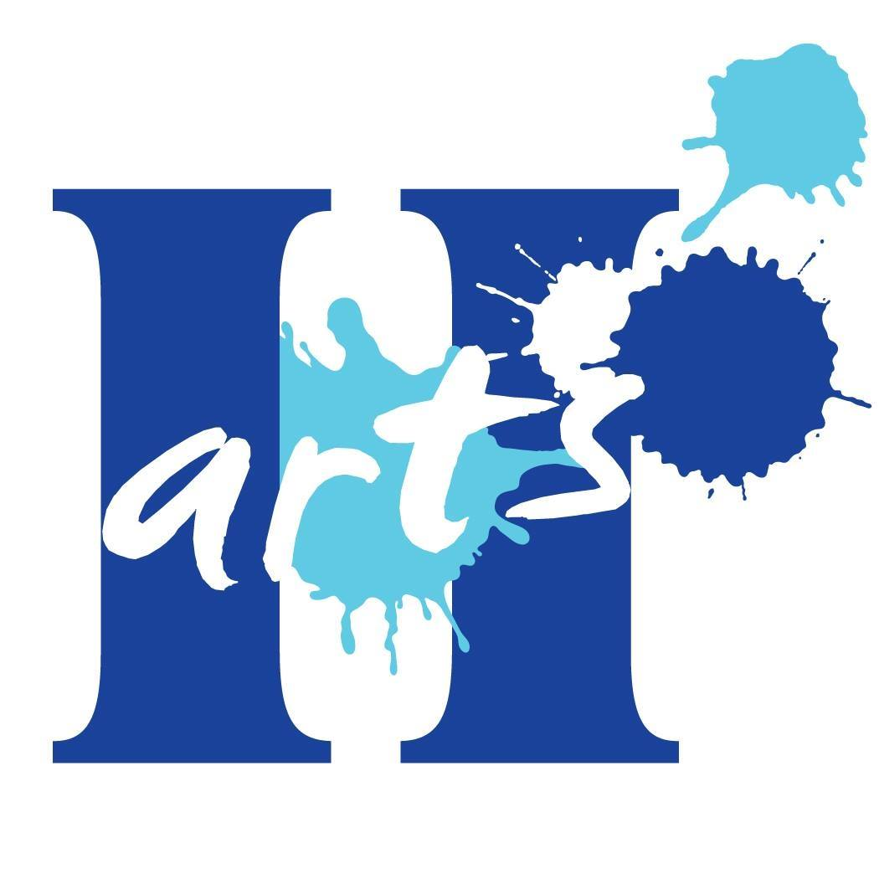

2018-19 Grant Guidelines and Application Form
Founded in June 2018, Haldane Arts Alliance (HAA) is a nonprofit arts organization. Our mission is to support and promote the performing, media, visual, and literary arts at Haldane by initiating art-related programs and performances, and by providing enrichment opportunities for students as well as professional development for staff.

HAA makes grants to help fund actions and initiatives that support our mission. Grant applications are accepted on an ongoing basis. Our grant committee evaluates applications and makes recommendations to our board. Our board votes on all grant-related items at quarterly meetings. Urgent applications can be considered by the committee and board.

Special note for the 2018-19 school year: This is HAA’s first year of existence, and our first fund-raising/grant-making year. Most HAA grants will be modest (up to $300). This year, the HAA board has a particular interest in supporting the purchase of arts-related materials, supplies, and equipment. However, we will gladly consider grant applications of all kinds.

Grant application instructions
1) Review HAA’s mission statement. It’s in the first paragraph on this page. Please make sure your grant application requests funds for an item, project or activity that supports our mission.

2) Complete the application form below. It’s in Word. Please save the final copy as a PDF.

3) Gather support documents. Cost documentation is mandatory. Other documents are optional, but they can strengthen your application and make your request more compelling.
- Cost documentation (mandatory): Document the cost of the item/activity/project you’d like HAA to support. Examples: Ads, estimates, invoices, links to prices re: online suppliers.
- Images (optional): Document a need. Or, show us an activity you’d like to try or to repeat.
- Support letters (optional): If you’ve got strong support from Haldane students, faculty, and/or administrators, attach letters of support, petitions, or other documentation.

4) Email the completed application form as a PDF attachment and all support documents to haldaneartsalliance@gmail.com. Email any questions to that address, too! NOTE: If your grant application requires timely action, please put URGENT in the subject line of your email.

5) Watch your email inbox. You’ll receive an email confirming your application was received. You will also receive an email with the HAA board’s final decision on your application. If you are awarded an HAA grant, you’ll receive instructions via email. Finally, you will receive a grant report form to complete after you have used your HAA grant to achieve your goal. Thank you!

Haldane Arts Alliance: 2018-19 Grant Application Form

Your completed application should not exceed two pages. Thank you!

1. WHO ARE YOU? Contact name, title, organization, email address, and telephone number.

2. WHAT DO YOU WANT HAA TO SUPPORT? Explain your request in 500 words or less!

3. WHY IS THIS A GOOD IDEA? How this item/activity/project supports the arts at Haldane.

4. WHO WILL BENEFIT AND HOW? Which students, grade levels, teachers?

5. FINANCIAL QUESTIONS. Complete questions A, B, and C below. An example is provided.

A. What is the total cost of the item/activity/project? Example: You want to take 100 sixth graders to a play. Tickets are $10/student. The total cost of this activity is $1,000 (100 x $10).

$____________________ Attach documentation re: item/activity/project cost to this application.

B. What amount are you requesting from HAA? Example: Each sixth grader will pay $5 to see the play (100 students x $5 = $500). You’d like HAA to pay the rest. Your request is $500.

$____________________ This can be the same as in Part A, or less than Part A, but not more!

C. If you are asking HAA to fund only a portion of the total cost, where will the rest of the funding come from? Is that funding confirmed? If not applicable, write “N/A.”

6. WHAT ELSE SHOULD WE KNOW? Did you tell us who, what, when, where, why, & how?

APPLICANT SIGNATURE: ___________________________________________________________

PRINT NAME: _________________________________ DATE SUBMITTED: __________________

Email a PDF of this application and all support documents to haldaneartsalliance@gmail.com. Thank you for supporting the arts at Haldane!

